Professional Skills assignment 4

Question 1.
$\rho_i=\frac{\sum_{k=1}^{\infty}\mu_{p_i} (x_k)\times(x_k)}{\sum_{k=1}^{\infty}\mu_{p_i}(x_k)}, \forall k = 1,2,3\cdots,m $\

Question 2.
$\rho_i=\frac{\int^m_k x_k\times\mu_{p_i}(x_k)dx}{\int^m_k\mu_{p_i}(x_k)dx}$

Question 3.
$S(x,z) = \bigg\{\frac{\mu_S(x,z)}{(x,z)}|(x,z)\in X \times Z\bigg\}\
$
Question 4.
\begin{equation}
J_{ind}(t) =
\begin{cases}
\text{1, \qquad \qquad if~n = 0} \newline
\frac {(\sum^n_{i=1} g_i)^2}{n\sum^n_{i=1} (g_i)^2},
\text{Otherwise}
\end{cases}
\end{equation}

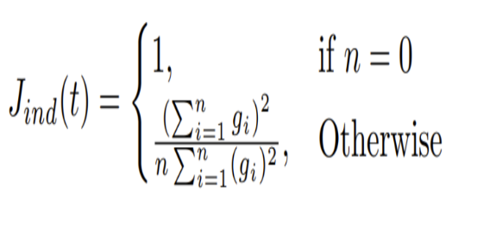


Q2.
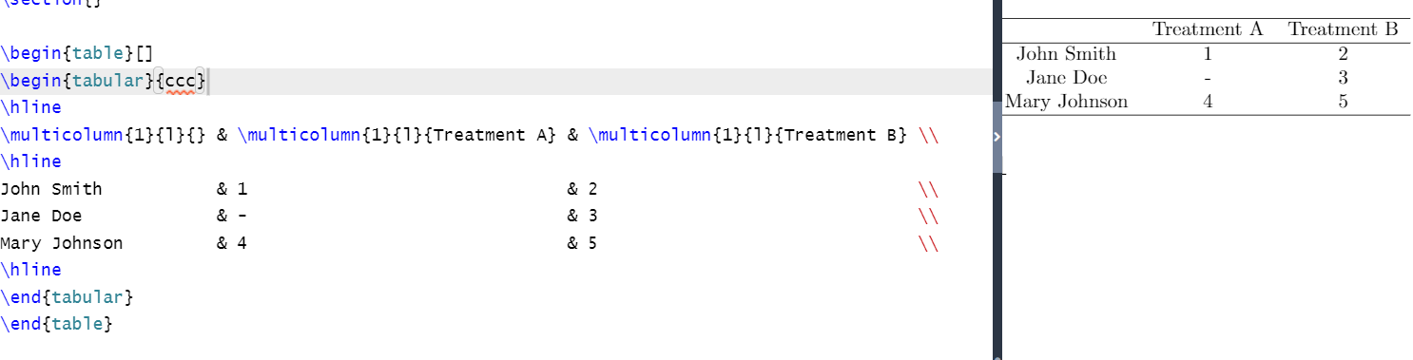

Q3.
